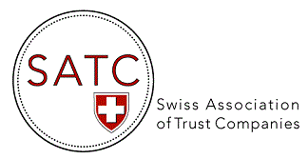

AGENDA 2020/2021
Events & Webinars

DATE | TOPIC
30 Oct 2020  10:00 AM | CRS/AEOI Audits of Trust Companies by the Federal Tax Administration: first findings  A 1.5 hr Webinar. Pascal MICHEL, team leader at the Federal Tax Administration, will talk about the experience gained in the first CRS/AEOI audits performed by the Federal Tax Administration within trust companies. He will share practical expertise and findings.
17 Nov 2020  2:00 PM | 13th EGM will be held by video conference (Zoom)  During second part Q&A with FINMA representatives  Your questions are welcome in advance!
1 Dec 2020  4:00 PM | “What can RegTech do for you?”  A 45 min Webinar by Ralf Huber of Apiax and Zoe Nicholas of Kendris, sharing their experiences with us.  A presentation of digital solutions for financial institutions to master regulatory monitoring, reporting and compliance.
Q1 2021  (date TBA) | Presentation of approved Supervisory Organisations
28 May 2021 | 14th AGM, at the Zunfthaus zur Zimmerleuten in Zurich
Q2 2021  (date TBA) | A Webinar by Emissary Holdings UK - “Global Disputes Solutions”  A way for trustees and family offices to manage international disputes and risks in cross border situations.

