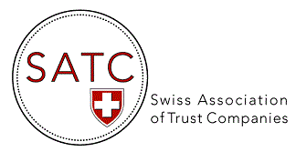

AGENDA 2025
Events & Webinars
DATE | TOPIC
7-8 May 2025 | Presence at the STEP Alpine Conference, Interlaken (as exhibitor)
22 May 2025 | 18th AGM of SATC, Bellevue Palace Grand Hotel, Bern
30 June 2025 | Ad hoc EGM of SATC, via video conference (ZOOM)
4 July 2025 | SATC Webinar on AI Empowerment of Fiduciary and Trust Companies : Trends & Developments (by Patrick Müller, Chairman of ITrust)
2 September 2025 | SATC Conference in London “Stability in a changing world”,  kindly hosted by Cazenove Capital
10 November 2025 | Presence at the STEP Arabia Conference, Abu Dhabi (as exhibitor)
November 2025 | 18th EGM of SATC, by video conference (ZOOM)

