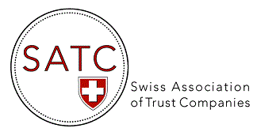

AGENDA 2022

Events & Webinars

DATE | TOPIC
10 March 2022  (11h00-12h00) | Panel discussion webinar on Trustee regulation/licensing  Panelists: Fabianne de Vos Burchart (Schellenberg Wittmer), Franziska Zobrist (Ramelet AG), Leonard Vijverberg (Lenz & Staehelin) and Marc Blumenfeld (Alithis AG)
4-5 May 2022 | Presence at the STEP Alpine Conference, Interlaken (as exhibitor)
17 May 2022 | 15th AGM of SATC, Zunfthaus zur Zimmerleuten, Zurich
31 August 2022 | Webinar on Cyber Security and Cyber Resilience (ZOOM)  With the collaboration of the NCSC and the Swiss FS-CSC
15 November 2022 | 15th EGM of SATC – video conference (ZOOM)

